**Business Problem**

Effective inventory and sales management are critical for optimizing profitability in the retail and wholesale industry. Companies need to ensure that they are not incurring losses due to inefficient pricing, poor inventory turnover or vendor dependency. The goal of this analysis is to:

* Identify underperforming brands that require promotional or pricing adjustments
* Determine top vendors contributing to sales on gross profit.
* Analyze the impact of bilk purchasing on unit costs.
* Assess inventory turnover to reduce holding costs and improve efficiency.
* Investigate the profitability variance between high performing and low performing vendors.

**Exploratory Data Analysis Insights**

**Summary Statistics**

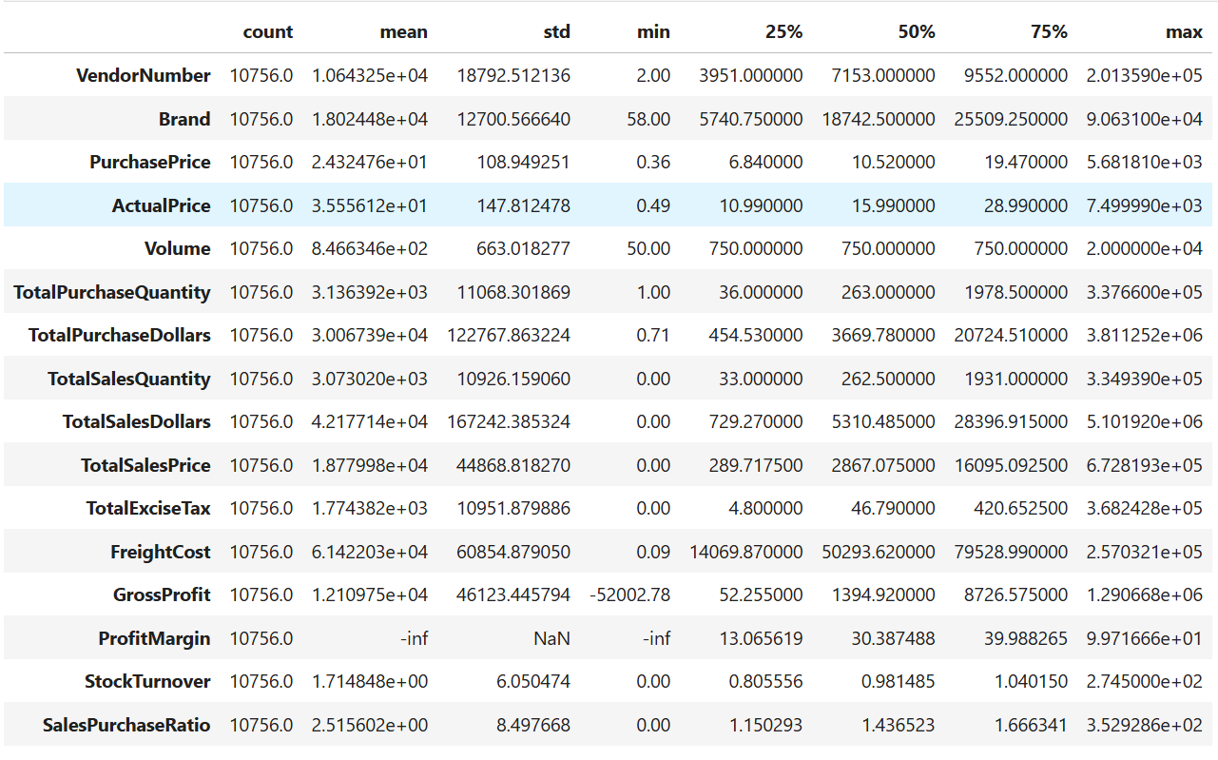

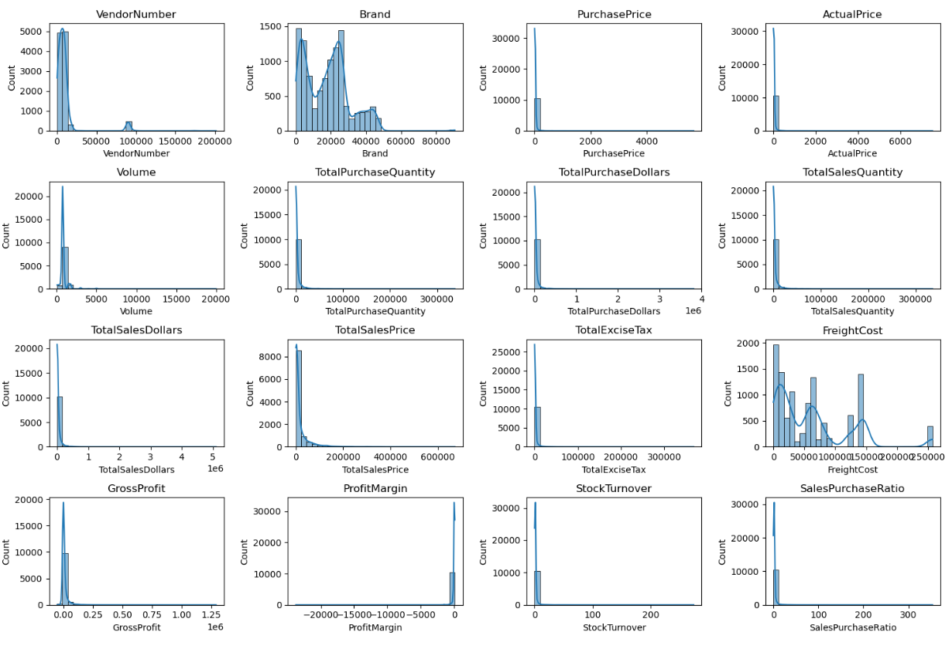

**Negative & Zero Values:**

**Gross Profit:** Minimum of -52,002.78 indicating potential losses due to high costs or heavy discounts. This could be due to selling at low prices than their purchase costs.

**Profit Margin:** Has a minimum of -infinity, which suggests instances where revenue is zero or even lower than the total cost, leading to extreme negative profit margins.

**Total Sales Quantity & Sales Dollars:** Minimum value are 0, meaning some of products were purchased but never sold. These could be slow moving or obstacle stock

**Outliers Indicated by High Std. Deviations:**

**Purchase & Actual Price:** The max values (5,681.81 & 7,499.99) are significantly Higher than the mean (24.39 & 35.64), indicating potential premium products.

**Freight Cost:** Huge variation, from 0.09 to 257,032, suggests logistics inefficiencies or bulk shipments.

**Stock Turnover:** Ranges from 0 to 274.5, implying some products sell extremely fast while others remain in stock indefinitely. Value more than 1 indicates that sold quantity for that product is higher than purchased quality due to either sales are being fulfilled from older stocks.

**Data Filtering:**

To enhance the reliability of the insights, we removed inconsistent data points where:

* Gross profit <=0 (to exclude transactions leading to losses).
* Profit Margin <=0 (to ensure analysis focuses on profitable transactions)
* Total Sales Quantity = 0 (to eliminate inventory that has never sold)

**Correlation Insights:**

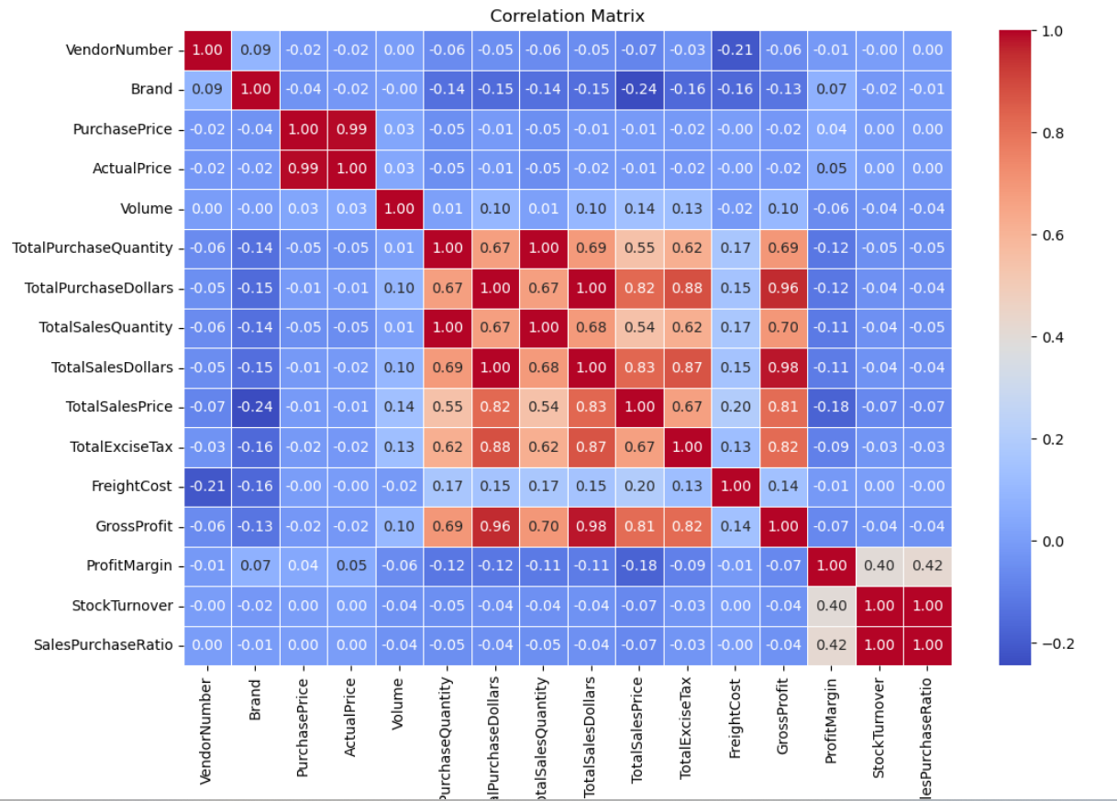

* Purchase Price has weak correlations with Total Sales Dollars (-0.012) and Gross Profit (-0.016), suggesting that price variations do not significantly impact sales revenue or profit.
* Strong correlation between total purchase quantity and total sales quantity (0.999), confirming efficient inventory turnover.
* Negative correlation between profit margin & total sales price (-0.179) suggests that as sales price increases, margins decrease, possibly due to competitive pricing pressures.
* Stock Turnover has a weak negative correlation with both Gross profit and Profit Margin, indicating that faster turnover does not necessarily result in higher profitability.

**Research Questions & Key Findings:**

**1. Brands for Promotional or Pricing Adjustments:**

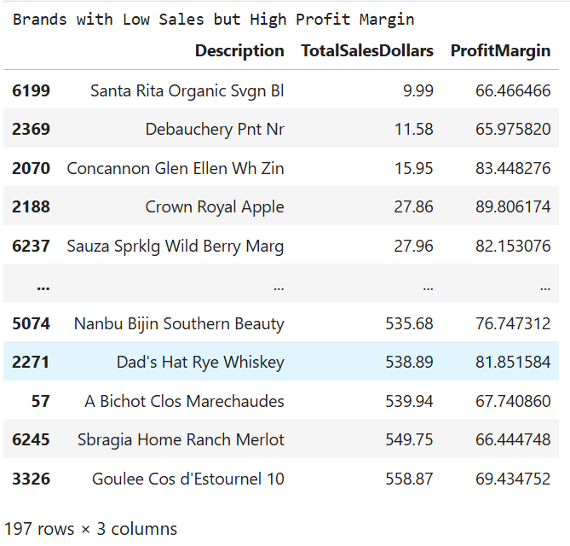

198 Brands exhibits lower sales but higher margins, which could benefits from targeted marketing, promotions or price optimizations to increase volume without compromising profitability.

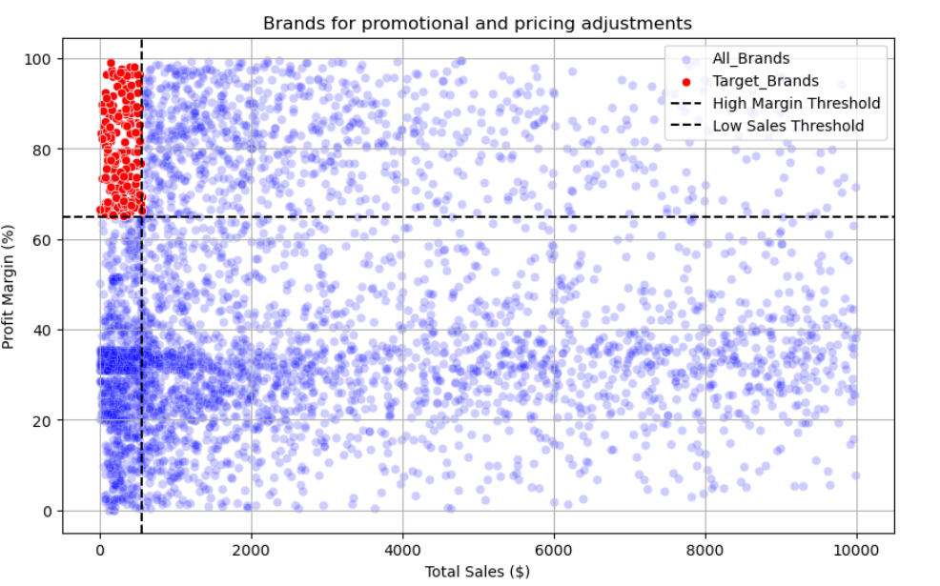

**2. Top Vendors by Sales & Purchase Contribution:**

The top 10 vendors contribute 65.69% of total purchases, while the remaining vendors contribute only 34.31%. This over-reliance on a few vendors may introduce risks such as supply chain disruptions, indicating a need for diversification.

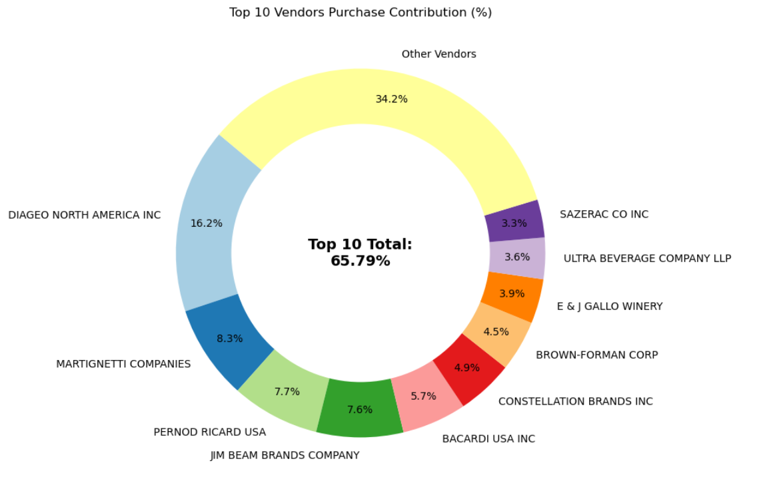

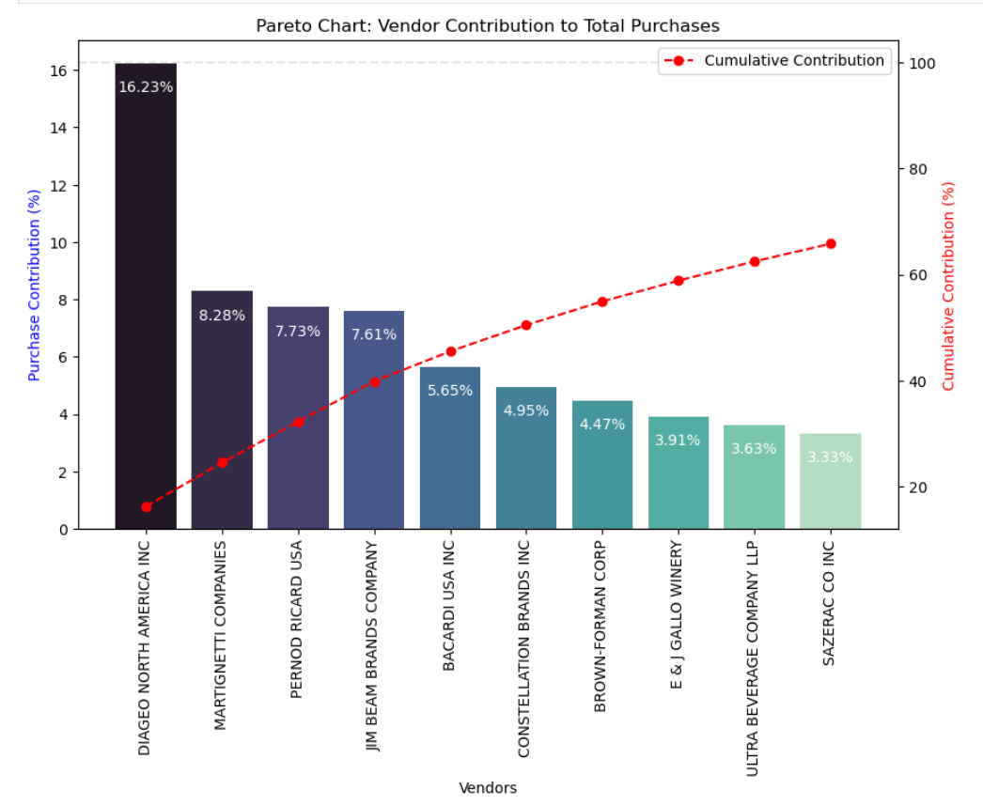

**3. Impact of Bulk Purchasing on Cost Savings:**

Vendors buying in large quantities receive a 72% lower unit cost ($10.78 per unit vs higher costs in smaller orders)

Bulk pricing strategies encourage larger orders, increasing total sales while maintaining profitability.

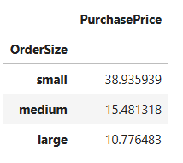

**4. Identify Vendors with Low Inventory Turnover:**

Total Unsold inventory Capital: $2.71M

Slow moving inventory increases storage costs, reduce cash flow efficiency and affects overall profitability.

Identifying vendors with low inventory turnover enables better stock management, minimizing financial strain.

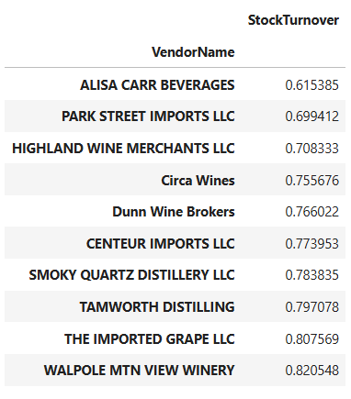 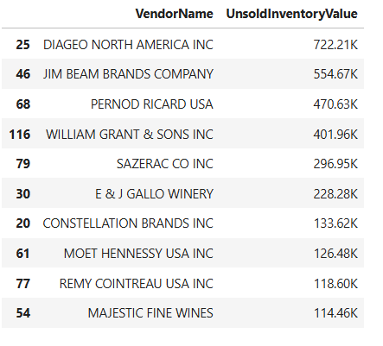

**Final Recommendations:**

* Re evaluate pricing for low sales, high margin brands to boosts sales volume without sacrificing profitability.
* Diversity vendor partnership to reduce dependency on a few supplies and mitigate supply chain risks.
* Leverage bulk purchasing advantages to maintain competitive pricing while optimizing inventory management.
* Optimize slow-moving inventory by adjusting quantities, launching clearance sales or revising storage strategies.
* Enhance marketing and distribution strategies for low performing vendors to drive higher sales volumes without compromising profit margins.
* By implementing these recommendations, the company can achieve sustainable profitability, mitigate risks and enhance overall operational efficiency.